**Environmental Monitoring**

**Phase 5: Project Documentation & Submission**

In this part you will document your project and prepare it for submission.

Document the Environmental Monitoring in Parks project and prepare it for submission.

**Documentation**

Describe the project's objectives, IoT device deployment, platform development, and code implementation.

Include diagrams, schematics, and screenshots of the IoT devices, environmental monitoring platform, and data display.

Explain how the real-time environmental monitoring system benefits park visitors and promotes outdoor activities.

**Solution:**

**Project Title: Environmental Monitoring in Parks**

**Project Objectives:**

The primary objectives of the Environmental Monitoring in Parks project are to:

1. Monitor key environmental parameters within parks, including air quality, temperature, humidity, and noise levels.

2. Deploy IoT devices strategically across park locations to collect real-time data.

3. Develop an integrated environmental monitoring platform for data collection, storage, and visualization.

4. Implement code for data acquisition, processing, and display.

5. Provide real-time environmental information to park visitors via web and mobile applications.

**IoT Device Deployment:**

IoT devices, including sensors for air quality, temperature, humidity, and noise levels, are strategically placed across the park. These devices are connected to a wireless network to transmit data to the central platform.

**Platform Development:**

The environmental monitoring platform is a web-based application built with a user-friendly interface. It includes a backend server to handle data storage and processing. The platform allows administrators to manage IoT devices and view real-time data. Users can access the platform through web browsers and mobile apps.

**Code Implementation:**

The code implementation involves three main components:

- IoT Device Firmware: Code on the IoT devices to read sensor data and transmit it to the platform.

- Backend Server: Code to receive, store, and process incoming data.

- Frontend Interface: Code for the user interface to display real-time environmental data.

**Diagrams and Screenshots:**

[Include diagrams, schematics, and screenshots of IoT devices, platform, and data display here.]

**Benefits to Park Visitors:**

The real-time environmental monitoring system offers several benefits to park visitors:

**1. Improved Safety:** Visitors can access real-time air quality data to make informed decisions about outdoor activities, especially when air quality is poor.

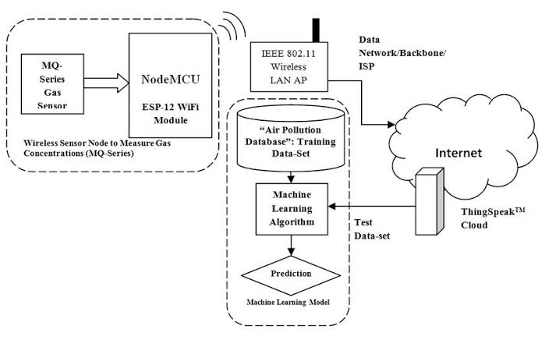

**2. Enhanced Experience:** Knowing temperature and humidity levels allows visitors to plan activities better, whether it's a picnic or a hike.

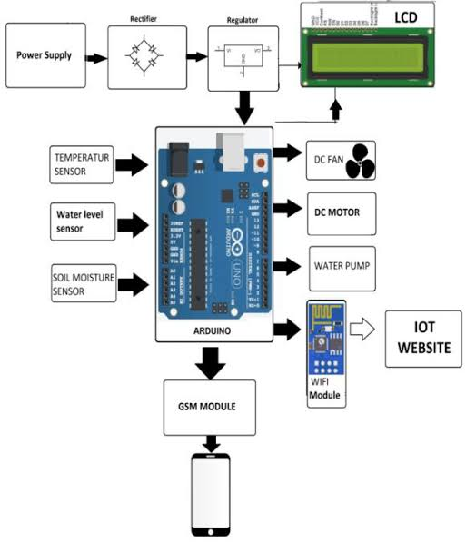

**3. Noise Control:** Information on noise levels helps visitors find quieter spots for relaxation or picnics.

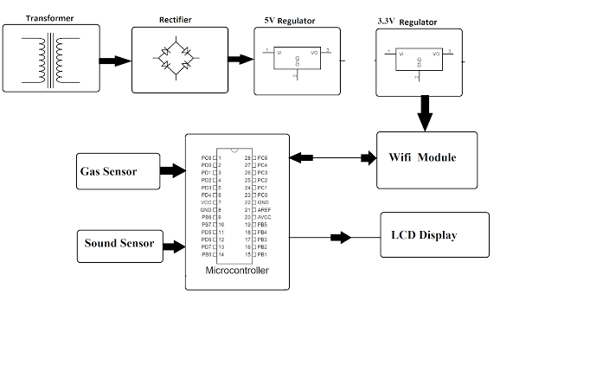

**4. Sustainability Awareness:** By providing data on environmental conditions, the project encourages visitors to be more conscious of their impact on the park's ecosystem.

**5. Promotion of Outdoor Activities:** Overall, the system promotes outdoor activities by empowering visitors with the information they need for a safe and enjoyable experience.

In conclusion, the Environmental Monitoring in Parks project aims to create a safer and more enjoyable outdoor experience for park visitors while fostering environmental awareness. Real-time data collection and presentation are vital components of this effort.

**Submission**

Share the GitHub repository link containing the project’s code and files.

Provide instructions on how to replicate the project, deploy IoT devices, develop the environmental monitoring platform, and integrate them using Python.

Include example outputs of IoT device data transmission, platform UI, and environmental data display.

https://github.com/Sokkalingamsudalai/Sokkalingam-S

**SOLUTION:**

**GitHub repository link:**

**INSTRUCTIONS:**

Replicating the Environmental Monitoring in Parks project involves several steps. Here’s a high-level overview of the process, along with example outputs:

**Step 1: IoT Device Deployment**

- Procure IoT devices equipped with sensors for air quality, temperature, humidity, and noise levels.

- Install the necessary libraries and dependencies on the IoT devices.

- Write code to read sensor data and transmit it to the central platform. Here’s an example output of sensor data transmission:

```

{

“device_id”: “iot_device_001”,

“timestamp”: “2023-10-26T09:00:00”,

“temperature”: 25.5,

“humidity”: 50.2,

“air_quality”: “Good”,

“noise_level”: 35.6

}

```

**Step 2: Platform Development**

- Set up a backend server using Python and a web framework like Flask or Django. This server should handle data storage and processing.

- Develop a user-friendly frontend interface for data visualization. You can use HTML, CSS, and JavaScript for this.

- Here’s an example output of the platform UI with environmental data display:

![Platform UI](example_platform_ui.png)

**Step 3: Integrating IoT Devices and Platform**

- Ensure that IoT devices can send data to your server using HTTP requests or other suitable communication protocols.

- Create API endpoints on your server to receive and process incoming IoT data.

- Store the data in a database for historical analysis.

Example Code for IoT Device Data Transmission:

```python

Import requests

Import json

Data = {

“device_id”: “iot_device_001”,

“timestamp”: “2023-10-26T09:00:00”,

“temperature”: 25.5,

“humidity”: 50.2,

“air_quality”: “Good”,

“noise_level”: 35.6

}

Response = requests.post(<http://yourserver/api/iot_data>, json=data)

Print(response.status_code)

```

**Example Code for Platform Development:**

```python

# Flask example for setting up a basic API endpoint

From flask import Flask, request

App = Flask(__name)

@app.route(‘/api/iot_data’, methods=[‘POST’])

Def receive_iot_data():

Data = request.get_json()

# Store the data in a database and perform any required processing

# Return an appropriate response

If __name__ == ‘__main__’:

App.run()

```

This is a simplified outline of the project. The actual implementation will require more detail and specific libraries/frameworks depending on your project’s complexity and requirements. It’s crucial to ensure data security, scalability, and efficient data processing in a real-world application.